Activity notice

Airborne Gravity Survey
Geoscience Australia and its partners, the South Australian Department of Planning, Transport and Infrastructure; and AuScope will be undertaking an airborne gravity survey in late-2023. This survey will collect new gravity data which will allow us to better understand height differences over the project area.
    - Airborne Gravity Survey Method
An airborne gravity survey has been determined as the most cost effective and efficient way of capturing data.
Light aircraft will be fitted with instruments called gravimeters that can measure extremely small variations in the Earth’s natural gravity field. The instruments do not emit any signals during the survey, thus there is no impact to people or animals.
No aerial photography will be captured as a part of the project.

What you may see or hear
A fixed-wing aircraft will fly in public airspace along straight paths about 5 km apart.
In order to obtain the required accuracy, aircraft will fly at a height no lower than 1,000 feet (300 m) in built-up urban areas and 500 feet (150 m) in rural areas.
Noise levels on the ground will be less than the sound of a passing motorbike, and last for about the same amount of time.

Timeframe and work area
The airborne survey is expected to be carried out over the planned survey area (see map) during late-2023.
More detailed information about timing will be released as it becomes available.

Safety compliance
To ensure safety, an independent air safety audit will be conducted on the aircraft and flight plans.
Flying will only occur during daylight hours under favourable weather conditions.
    - For further information

    - Geoscience Australia
    - Email: AGRSGravity@ga.gov.au
    - Phone: 1800 800 173

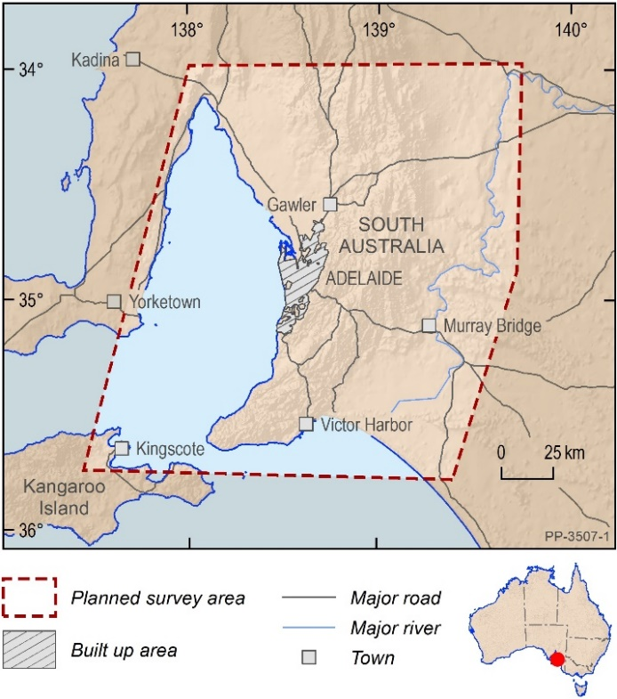

Figure 1: Planned airborne gravity survey area
Figure 2: DHC-6 Twin Otter fixed wing aircraft C-GSGP

Important to know
Pre-competitive data acquired by GA will be publicly available after quality control and assurance checks have been performed. Public release of this information may contain explicit spatial location information, such as specific deployment locations and/or areas which may be interpreted as containing groundwater and resource potential

